South China University of Technology
《Database》Experiment Report
Experiment Title： Query database with MySQL
Name： Student ID：
Class： 22计科全英创新班 Group： None
Collaborator： None
Teacher： 余志文/汪秀敏
Description
【Objective and Requirement】
1) Create a table named Student using command Create Table. The table structure is as follows:
Column | Type | Length | Note
ID | Varchar | 20 | Student’s ID
Name | Varchar | 10 | Student’s Name
Age | Int |  | Student’s Age
Department | Varchar | 30 | Student’s Dept
2) Create a table named Course using command Create Table. The table structure is as follows:
Column | Type | Length | Note
CourseID | Varchar | 15 | Course’s ID
CourseName | Varchar | 30 | Course’s Name
CourseBefore | Varchar | 15 | Previous Course
3) Create a table named Choose using command Create Table. The table structure is as follows:
Column | Type | Length | Note
ID | Varchar | 20 | Student’s ID
CourseID | Varchar | 15 | Course’s ID
Score | Dec | 5,2 | Student’s Score
4) Insert 3 records into table Student using command Insert.
ID | Name | Age | Department
00001 | ZhangSan | 20 | Computer Science
00002 | LiSi | 19 | Computer Science
00003 | WangWu | 21 | Computer Science
5) Insert 3 records into table Course using command Insert
CourseID | CourseName | CourseBefore
C1 | Introduction to Computer | －
C2 | PASCAL Programming Language | C1
C3 | Data Structure | C2
6) Insert 7 records into table Choose using command Insert
ID | CourseID | Score
00001 | C1 | 95
00001 | C2 | 80
00001 | C3 | 84
00002 | C1 | 80
00002 | C2 | 85
00003 | C1 | 78
00003 | C3 | 70
7) Select the students’ ID and Name in Computer Science department using command select.
8) Select the students’ ID, Name, CourseName and Score using command select.
9) Select all students’ Information in descending order of the students’ ID.
10) Select every student’s average score.
11) Select the number of courses a student has chosen.
12) Select the number of students choosing a specific course.
13) Select the students’ ID who have chosen course C1 and got score over 80.
14) Select the students’ ID who have chosen course C2.
15) Select the average age of students in every department.
【Environment】
Windows 11, MySQL 8.3.0, MySQL Workbench8.0.36-winx64
Content
【Procedure】
(1, 2, 3)
Firstly, I create 3 tables as the demand (Code see in Appendix).
(4, 5, 6)
Then, I insert information into each table (Code see in Appendix).
(7) (8)
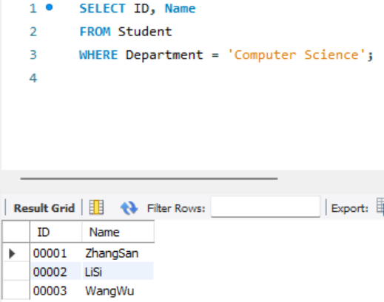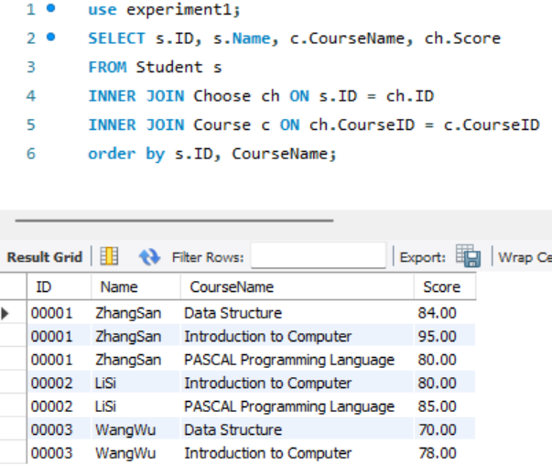
(9) (10)
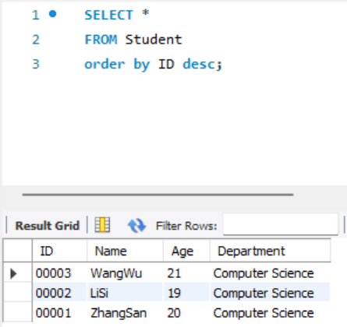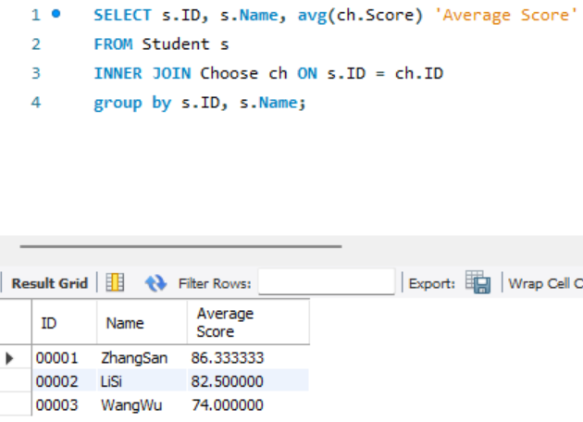
(11) (12)
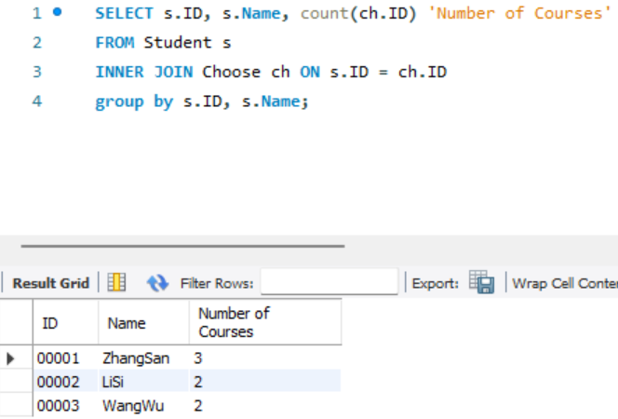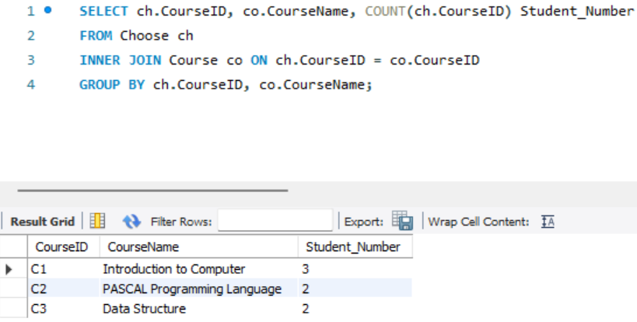
(13) (14)
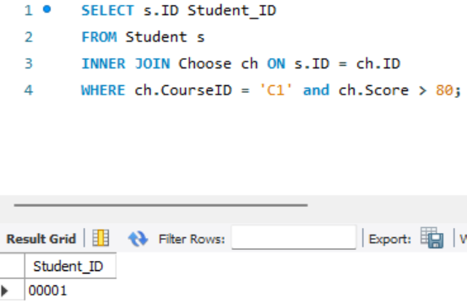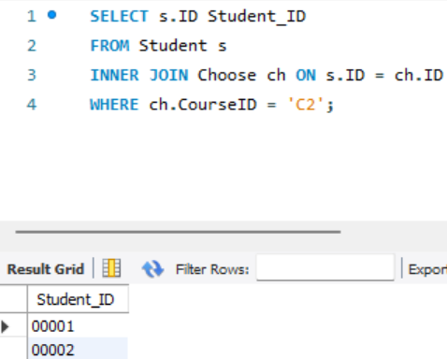
(15)
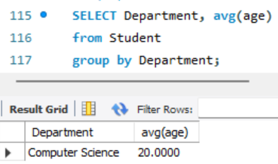
Conclusion
Through this experiment, I firstly used MySQL to realize a database and table operation on the computer, which is very benefit for me to learn this course Database.
Teacher’s Comments and Score
Comment：

Score： Signature：
Date：
Appendix
drop database if exists experiment1;
CREATE DATABASE if not exists experiment1;

use experiment1;
-- (1)
CREATE TABLE Student(
ID VARCHAR (20) COMMENT 'Student\'s ID',
Name VARCHAR (10) COMMENT 'Student\'s Name',
Age INT COMMENT 'Student\'s Age',
Department VARCHAR(30) COMMENT 'Student\'s Dept'
);
-- (2)
CREATE TABLE Course(
CourseID VARCHAR (15) COMMENT 'Course\'s ID',
CourseName VARCHAR (30) COMMENT 'Course\'s Name',
CourseBefore VARCHAR (15) NOT NULL DEFAULT '-' COMMENT 'Previous Course'
);
-- (3)
CREATE TABLE Choose(
ID VARCHAR (20) COMMENT 'Student\'s ID',
CourseID VARCHAR (15) COMMENT 'Course\'s ID',
Score DECIMAL (5,2) COMMENT 'Student\'s Score'
);

-- (4)
INSERT INTO Student (ID, Name, Age, Department)
VALUES('00001', 'ZhangSan', 20, 'Computer Science');

INSERT INTO Student (ID, Name, Age, Department)
VALUES('00002', 'LiSi', 19, 'Computer Science');

INSERT INTO Student (ID, Name, Age, Department)
VALUES('00003', 'WangWu', 21, 'Computer Science');

-- (5)
INSERT INTO Course (CourseID, CourseName)
VALUES('C1','Introduction to Computer');

INSERT INTO Course (CourseID, CourseName, CourseBefore)
VALUES('C2','PASCAL Programming Language', 'C1');

INSERT INTO Course (CourseID, CourseName, CourseBefore)
VALUES('C3','Data Structure', 'C2');

-- (6)
INSERT INTO Choose (ID, CourseID, Score)
VALUES('00001','C1',95);

INSERT INTO Choose (ID, CourseID, Score)
VALUES('00001','C2',80);

INSERT INTO Choose (ID, CourseID, Score)
VALUES('00001','C3',84);

INSERT INTO Choose (ID, CourseID, Score)
VALUES('00002','C1',80);

INSERT INTO Choose (ID, CourseID, Score)
VALUES('00002','C2',85);

INSERT INTO Choose (ID, CourseID, Score)
VALUES('00003','C1',78);

INSERT INTO Choose (ID, CourseID, Score)
VALUES('00003','C3',70);

-- (7)
SELECT ID, Name
FROM Student
WHERE Department = 'Computer Science';

-- (8)
SELECT s.ID, s.Name, c.CourseName, ch.Score
FROM Student s
INNER JOIN Choose ch ON s.ID = ch.ID
INNER JOIN Course c ON ch.CourseID = c.CourseID
order by s.ID, CourseName;

-- (9)
SELECT *
FROM Student
order by ID desc;

-- (10)
SELECT s.ID, s.Name, avg(ch.Score) 'Average Score'
FROM Student s
INNER JOIN Choose ch ON s.ID = ch.ID
group by s.ID, s.Name;

-- (11)
SELECT s.ID, s.Name, count(ch.ID) 'Number of Courses'
FROM Student s
INNER JOIN Choose ch ON s.ID = ch.ID
group by s.ID, s.Name;

-- (12)
SELECT ch.CourseID, co.CourseName, COUNT(ch.CourseID) Student_Number
FROM Choose ch
INNER JOIN Course co ON ch.CourseID = co.CourseID
GROUP BY ch.CourseID, co.CourseName;

-- (13)
SELECT s.ID Student_ID
FROM Student s
INNER JOIN Choose ch ON s.ID = ch.ID
WHERE ch.CourseID = 'C1' and ch.Score > 80;

-- (14)
SELECT s.ID Student_ID
FROM Student s
INNER JOIN Choose ch ON s.ID = ch.ID
WHERE ch.CourseID = 'C2';

-- (15)
SELECT Department, avg(age)
from Student
group by Department;

